

Computer Games Development CW208

Underkill - GDD

Year III

|  |  |
| --- | --- |
| Jamie Jackson  C00182414 | Sean Byrne  C00180780 |
| 09/02/2016 | |

# 

Table of Contents

The Elevator Pitch:

Player Experience Goals:

Project Introduction:

Background:

Game Progression:

Game Description:

New Game:

Load Game:

Quit Game:

Settings:

Features:

Mechanics

Moving:

Shooting:

Audio Elements:

Levels:

Gameplay:

The Game World:

Overview:

Post Apocalyptic Era:

The Maze:

The Physical World:

Overview:

Key Locations:

Travel:

Scale:

Objects:

Day and Night:

Camera and Game Engine:

Overview:

Camera Detail:

Collision Detection:

User Interface:

Overview:

HUD:

Pickups:

Weapons:

Overview:

Weapon Categories:

# The Elevator Pitch:

Underkill is a 2D Top-Down Shooter game where the player must fight off zombies whilst making their way through a maze.

# Player Experience Goals:

The overall experience we hope the achieve with this game are fun and casual experience. The player will feel a sense of playfulness whilst still feeling a sense of tension as they attempt to fight their way through levels.

# Project Introduction:

The game that we have decided to is a top-down shooter maze game. The main objective of the player will be to fight off hordes of zombies whilst trying to reach the end of the maze. As the player progresses through the levels the zombies will become more difficult to kill and the maze will be more difficult to find your way out of.

We decided to do this project with the goal of creating a simple, yet fun and fast paced top-down shooter. The target audience for the game is 13 years of age and above, as there is fantasy violence. We hope to create a polished game that can compete with games already on the app store.

# Background:

There were a couple of games that had a major influence on our final decision. The first of which being Dead Ops Arcade.

**Dead Ops Arcade:** This is a mini game that is a part of Call of Duty: Black Ops. It is also a top down shooter zombie game that uses a controller for control. What attracted us to this game was how smooth the controls are, and this removed the doubt we had that a controller could make a top-down shooter difficult to play.

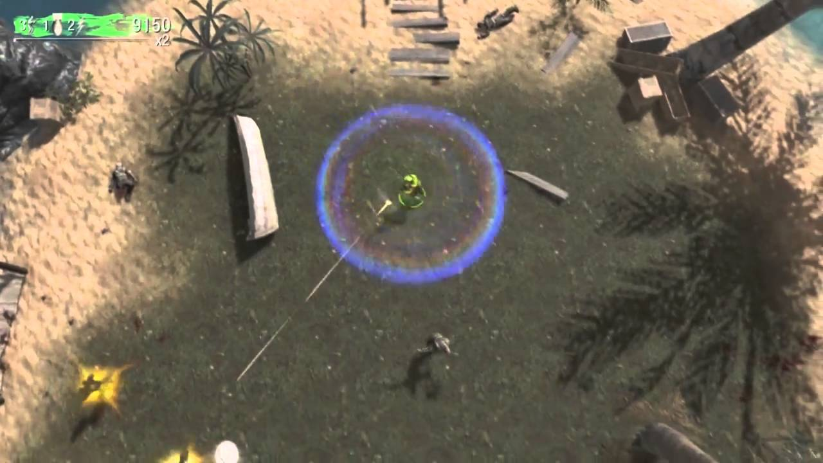

Although we enjoyed how Dead Ops Arcade plays, we thought the Heads Up Display could be improved. We might improve upon this by spreading different parts of the HUD across different sections of the screen but this is still to be confirmed.

Something else which had an influence on what direction we would take our own design wasn’t actually a video game but instead a maze. Finding your way out of a maze can be difficult as it is but to have to worry about fighting off zombies in the meantime will only add to the struggle. However finding your way out of a maze when you have a top-down perspective could make the experience easy and perhaps boring so to combat this the player will only be able to see a small portion of the maze.

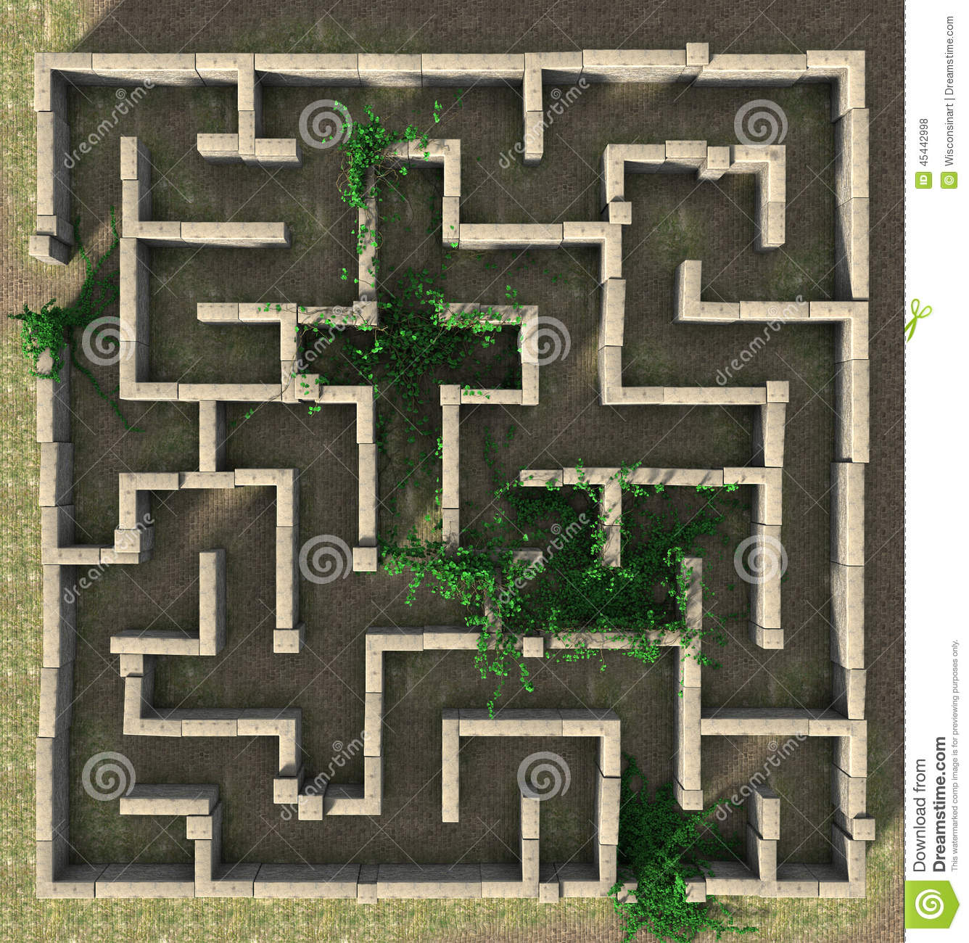

# Game Progression:

The levels in the game are based on simple mazes with enemy zombies attempting to stop you. The player will complete a level by moving from the starting point, to the end point of the maze. Levels will start out quite easy and gradually get harder the more levels the player completes. In the earlier levels the player will be attacked by a small number of enemies and as the player progresses the number of hostile zombies in the level will increase. The easier levels will have multiple ways to complete, however the more difficult levels may only have one correct path for the player to take.

# Game Description:

The player will open the application and will be brought to the main menu. From here they will select one of a number of options. (New Game, Load Game, Settings, Quit Game etc.) The player will be aware of which option they are selecting via a handprint under the currently selected option.

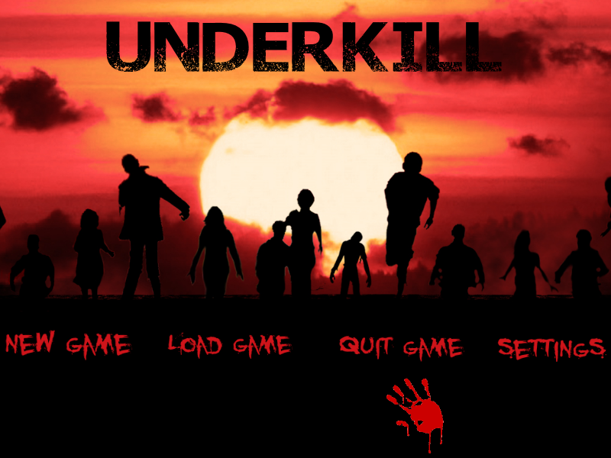

## New Game:

Upon selecting the “New Game” option, the player will be asked to input the name of their save file. This will then be saved for future use.   
As the player has started a new game they will begin on the tutorial level. On this level the player will be introduced to the controls and will get a feel for the game-play.  
After completing the tutorial level the player will be placed into the first level. The player will be given an objective to complete before escaping the maze, if this objective is completed the player will receive a bonus (score bonus/ammo/weapons). This will be the general theme for all other levels. After completing a level the player's progress will be saved.

## Load Game:

Upon selecting the “Load Game” option, the player will be placed back in their original game. They will return to the start of the level that they were last on because the player will be unable to save the game mid-level. The player will then be able to play on as normal.

## Quit Game:

Upon selecting the “Quit Game” option, the player will be asked to confirm whether they want to quit the game, if yes the application will close. However if the player cancels the quit game the will be returned to the main menu.

## Settings:

Upon selecting the “Settings” option, the player will be brought to a screen where they can change a number of options (Sounds/Volume/Controls etc.). An image of a labelled controller will also be displayed on the screen, this will show the controls to the player. The player will then have to confirm their changes. The player will then be brought back to the main menu.

# Features:

## Mechanics

### Moving:

* The player controls his movement using the left analogue stick on the controller. The direction in which the player points the stick directly corresponds with the direction in which the player moves.
* The player’s movement will stop if he is colliding with a wall.
* The player controls his rotation using the right analogue stick. The player will point in the same direction that the right stick is pointed.

### Shooting:

* The player can shoot their gun by pressing the RB button on the controller.
* Depending on the weapon that the player is using, a certain amount of bullets can be fired before the gun must be reloaded.
* Bullets will be deleted when they collide with an object, such as an enemy or a wall.

### Audio Elements:

* Background music will be added to the game.
* Each level will have it’s own background music, the music added to each level will be related to the visual appearance of the level.
* There will be music added to the menu screen, this will deliver an eery feeling to the player.
* All background music can be muted using the Start button on the controller.
* In game elements will have their own sound effects, such as bullets and a reloading sound for the gun.
* When the player shoots their gun you will be able to hear a gunshot, this sound will differ depending on what gun the player is using.

### Levels:

* Each level will have a different layout.
* Each level will take place in it’s own environment
* The higher level the player is on, the more difficult will be.
* The player progresses by getting through each maze.

### Gameplay:

* The main objective of this game is to escape a maze whilst fighting off hordes of zombies. The player will have to regroup with his allies and assist them in escaping the maze.
* The amount of weapons and ammunition will be lacking so it’s important for the player to conserve where they can by steering clear of battles that can be avoided.
* The player will have a limited amount of health so it’s vital that the player avoids getting too close to a zombie. Health packs may be available at some parts of the map but there will not be an abundance of them.
* There will also be a number of sound effects to enhance the player's experience such as bullet sounds, explosions, alarms, music etc.

# The Game World:

## Overview:

Provide an overview to the game world.

## Post Apocalyptic Era:

The game takes place in a post apocalyptic era. The location of this is unknown by the player but clues are given to him as the game goes on. The environment is dark and frightening. The only light is provided by the burning cars and the flame-engulfed houses. The player will encounter torn up street signs along the way as he attempts to discover the location of his presence.

## The Maze:

The player finds himself enclosed in a maze, finding a way out is his top priority. Unfortunately it is not that easy as he is faced with the task of fighting off hordes of zombies whilst trying to regroup with his allies.

# The Physical World:

## Overview:

The physical world will consist of buildings and walls that will enclose the player, this will act as a maze for the player to navigate through. The player could possible spend time clearing out streets only to find that they have been travelling down a dead end. Or perhaps the player will have to purposely travel a different direction then they were originally intending to locate one of their allies. These are just a few impacts that the physical world can have on the play-style that the player adapts.

## Key Locations:

The player will start the game on the peripheral of the maze and he will have to find out which side the exit is on. The other key location is of course the exit. The player will have to travel through the maze to find the exit, the exit may be guarded by a boss zombie so it’s important that the player has the armory capable of taking on the boss.

## Travel:

The player will use a controller to control the movement of the player. The left-stick on the controller will correspond with the direction that the player moves. The right-stick will control the player's rotation.

## Scale:

Scaling will be a major part of the game as having the entire map visible on the screen will make the maze easier to escape and will result in the player not being able to see some of the details in the map. To combat this we will scale the map so that a small section can only be visible by the player. The player will be located in the centre of the screen to help them see the surrounding area.

## Objects:

The only weapons that the player will be able to use are the ones that they find around the map. At the start of each level the player will be in close proximity to a small pistol with a small number of bullets. This will not get the player through the entire level alone so they will have to collect other armory from crates located around the map. Along with armory crates there will also be health crates, these will be just as vital to the players survival as the armory crates.

## Day and Night:

Day or night will depend on the level that the player is currently playing. Some levels will be at night and others will be during the day.

# Camera and Game Engine:

## Overview:

The camera will only display a fraction of the level at any one time. The camera will follow the player through the maze. The width of the maze walls will be able to equally divide into our screen viewing size so that the player will not be able to see too far ahead of the maze. The player’s character will remain in the centre of the screen at all times.

## Camera Detail:

The camera will show the player in the centre of the screen at all times. This will make the game look much cleaner and smoother than it otherwise would have been.

## Collision Detection:

The collision detection we are planning to implement will be box to box collision. We will be using box collision on the bounds of the objects as we are not using any game engine to handle the collision for us. We decided to use box collision ahead of circular collision detection as we felt that our objects would better fit inside a box rather than a circle and that this would lead to more accurate collision detection. We also considered per pixel collision but although this may be slightly more accurate, the performance of the game would suffer due to how expensive it is to compute.

# User Interface:

## Overview:

The UI in the game will have a post apocalyptic and gore effect to it. The menu system will have the bloody text effect throughout as shown below, the bloody hand print will act as a selector so the player knows which option they are selecting.

### UndekillCover w Buttons.png

### 

### 

### 

### 

## HUD:

The in game HUD will be very basic but the artwork will suit the game and will look very clean. The HUD will show the player's current weapon, remaining ammo, current level etc. The HUD will also display a radar that shows objects, enemies and friendly character.

## Pickups:

Pickups will be scattered across different sections of the map. Each different pickup will have their own distinct icon. These icons will be blown up on screen so the player can clearly recognise them.

# Weapons:

## Overview:

There will be a default pistol for the player that the player will have in the first level. This weapon will have limited ammo. Other weapons are acquirable as pick ups during each level. Ammo will need to be acquired by the player throughout the level. If the player loses all ammo in a certain gun, that gun will remain in the player's inventory and will be usable again once more ammo is collected.

## Weapon Categories:

The weapons will be split into 3 tiers. The 1st tier will be compact weapons (pistols,SMGs etc). The 2nd tier will be machine guns (assault rifles, LMGs etc). The 3rd tier will be explosives (grenade launchers, rpgs etc). Thus there will be 3 tiers of ammo, one for each category.